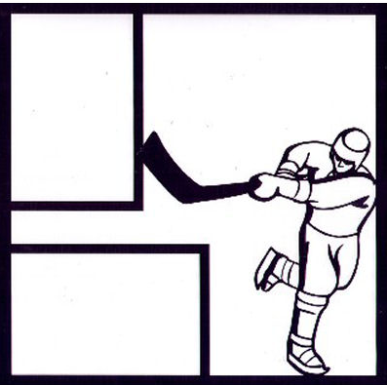
Sponsors
Wittock Kitchen and Bath, Basic Rubber & Plastics Company, Dwyer & Sons Volvo Subaru, Dr. Hersh & Beattie Orthodontics, Library Sports Pug & Grill, Crystal Creek Assisted Living, Embroider Me, Olga’s, Bayside Sports Grill, Gordon Chiropractic, Garden City Upholstering, Creative Designs Plus Inc, Frankie Photography, Luzynski & Associates P.C., Salon del Sol, Chuck Hellebuyck’s Electronic Products

Knights Hockey Players & Coaches: No Charge
All Family Members: $20 per person
Buffet Dinner, Non-Alcoholic Beverages & Dessert provided
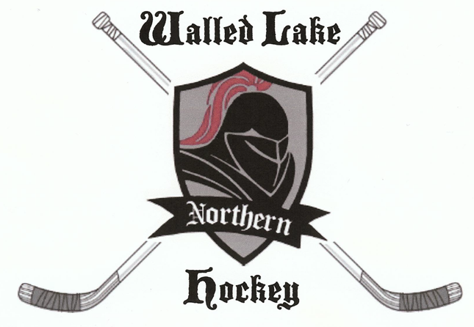

You are invited to the
Walled Lake Northern Hockey Banquet
Sunday March 18, 2012
11:30 am
White Lake Oaks
991 Williams Lake Road, White Lake MI, 48386

_____________________________________________________________________________________
2011-2012 WLN Knights Hockey Banquet Response Card

Total Number attending (including player): ____________________
Player’s name: ___________________________________________________________________________
Family Members name(s) attending: __________________________________________________________
Amount Enclosed: $ __________________________
Please Make Checks Payable to: WLN Varsity Hockey
RSVP & Payment by: Monday March 9th, 2012
Please Detach and Mail Response Card to:
Michelle Fishback
3670 Elder Rd. South West Bloomfield 48324

